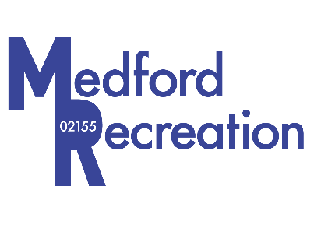
Recreation Department
City of Medford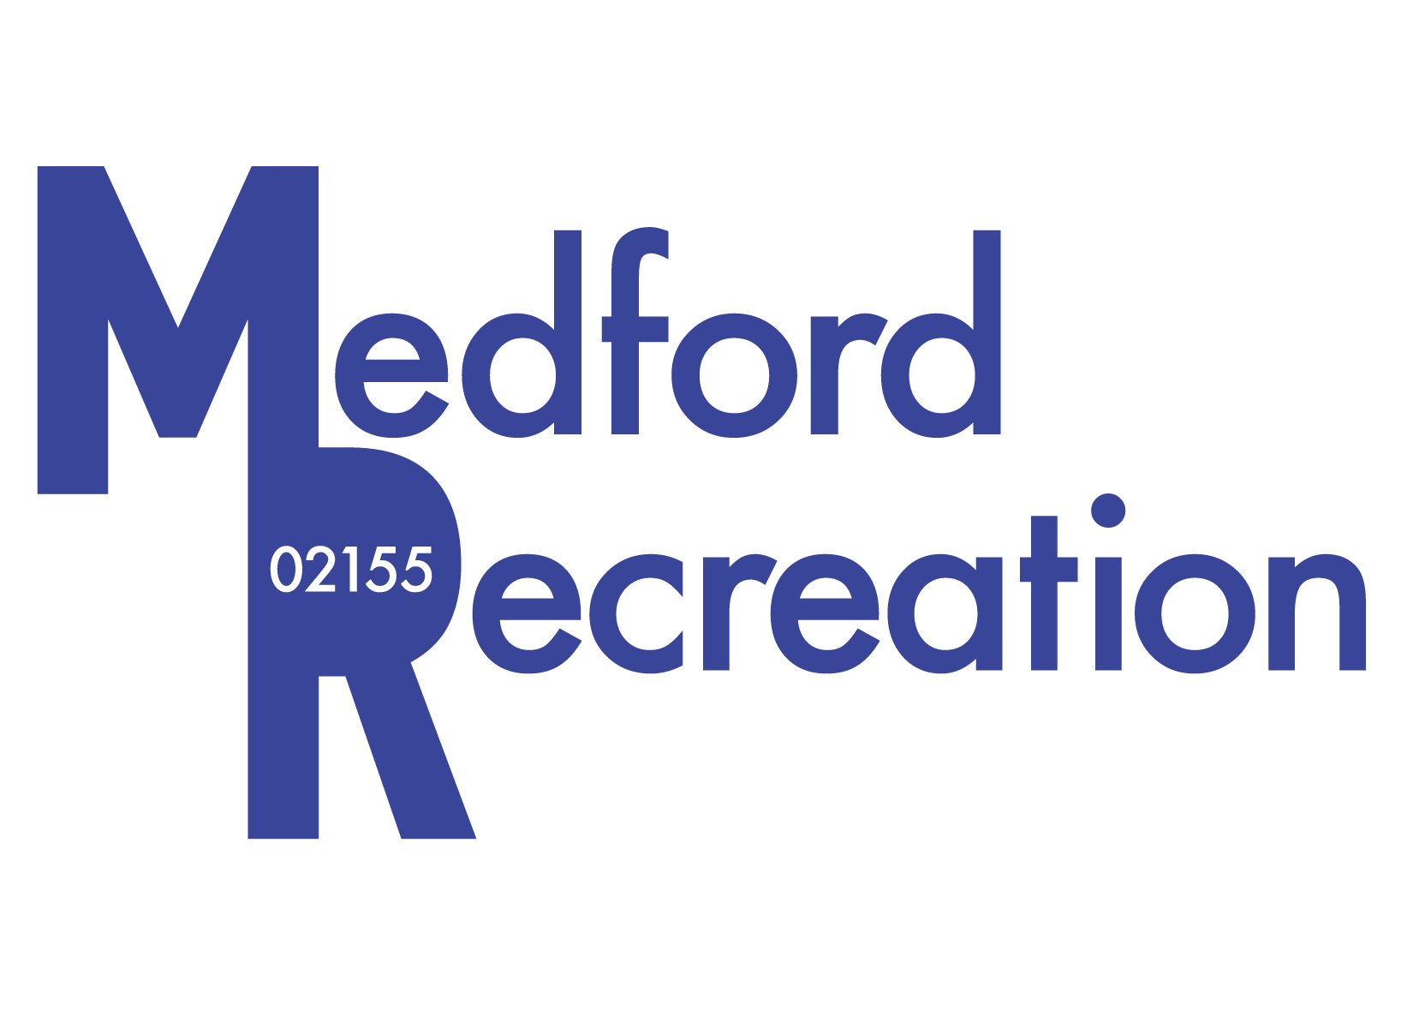

30 Forest Street
Kevin J. Bailey
Director of Recreation

TDD: (781) 393-2516
Medford, Massachusetts 02155
Telephone (781) 393-2486

COVID-19 Winter Safety Plan

Beginning December 6th, 2020, the Recreation Department will be moving their office and programs back to the Recreation Center, located on 30 Forest Street. By moving indoors, the following updates have been added to our COVID Safety Plan.

- All patrons must wear a face mask, covering the nose and mouth while in the Recreation Center. This includes participants, spectators, coaches and staff.
- Recreation employees can not remove their face mask unless in their office with the door shut.
- To help limit occupancy, Recreation will be asking spectators to be kept to an absolute minimum.

Cleaning Plan:

Weekdays: Recreation Staff will disinfect high touched surface areas including the front desk, hand rails, and bathrooms in the morning between 8:30am-9:00am. Between 5:30pm-6:30pm, staff will disinfect again as programs transitions from the afterschool program to recreation activities.

Weekends: All programs on Saturday and Sunday with have a 30-minute break between to allow Recreation Staff to disinfect high touched surface areas and any equipment before being put back in the storage closet.

Hand sanitizer will be made available at the front desk.

Program Planning:

To promote social distancing, only 10 people will be allowed in each program. Only one program at a time will be scheduled in the gym and dividing of the court will not be allowed. A 30 minute transition time will be scheduled between programs.

Drop-in programs will not be allowed this Winter. Registration will be required to control occupancy.

