Inclement Weather, Program Withdrawals, Low Enrollment and Refund Policy
The goal of the Medford Recreation Department is to offer quality programming and services to the City of Medford. Our Department understands there are unforeseen scheduling conflicts and emergencies that may require patrons to withdraw or cancel a program. Below is our policy on how we communicate with the public on cancellation and how we can accommodate refunds and issue credits without compromising the programs and services we offer.
Inclement Weather:
Snow:
During the school year, If Medford Public Schools are closed due to weather, morning Recreation programs (before 12pm) will also be cancelled. An update will be made by 12pm to decide if evening programs and facilities can be open.
For storms impacted during non-school days, Recreation will consult with DPW to decide if facilities and programs can remain open.
Rain & Thunderstorms:
For programs that are scheduled to be located outdoors, the Recreation Department along with the instructor will decide if class needs to be cancelled due to rain. Depending on the program, we may continue to run class in the rain. If thunderstorms are forecasted, for the safety of the participants, we will cancel class. Please note: Weather changes very quickly and while we try our best to give ample notification before class, in some circumstances, we need to give short notice. If rain or thunderstorms are forecasted for the day, we recommend you check our website before leaving for class. Please note: Some programs that meet multiple days or are subsidized may not receive credit for inclement weather. This will be noted in the course description.

Credits for Inclement Weather:
If class is cancelled due to unforeseen circumstances such as inclement weather, a credit will be placed on your household account for the cancelled class. Credits can be applied for a future recreation program. The Recreation Department does not schedule make up classes for cancelled classes.

Mechanical Failure / Environmental Closures:
If a facility is closed due to mechanical failure (example: broken compressors at the rink or chlorine feeder broken at Tufts Pool) we will post on our website and send an email to membership holders when possible. Refunds or partial credits on membership will not be issued unless the facility is closed for more than seven days. Environmental closures such as elevated e-coli at Wright’s Pond are beyond the department’s control and are not eligible for refunds or credits.

Notification of Cancellations:
When Recreation staff are notified of a facility closure or program cancellation, our first step is to post an alert on our website. Many of our front-line staff are trained in how to post this alert and can be accomplished quickly. Below is an example of what an alert would look like. Please remember to refresh your web browser when viewing our website.

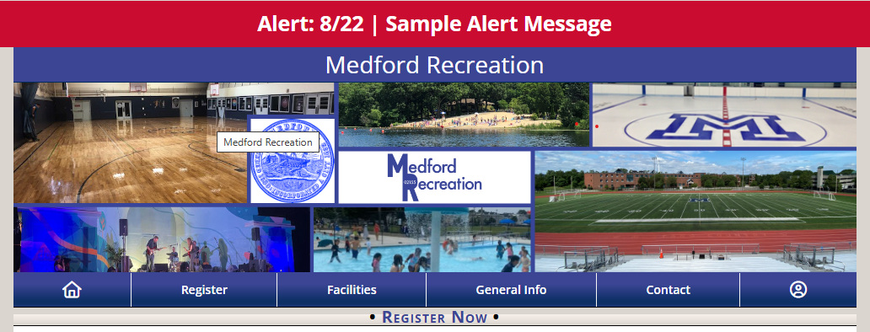

When possible, management will send an email to participants and/or memberships. This requires a manager to be at the office and may not be possible with short, unexpected closures.

Refund & Program Withdrawal Policy:
Below is an overview of when refunds will be issued…
- All refunds requests are subject to review by the Director of Recreation.
- Programs under $20 or will not be refunded. Only credits will be issued.
- If a participant wishes to withdraw from a program, they will receive a credit to their account to be applied for a future Medford Recreation activity. All credits must be used within one year. No refunds (cash back) will be given from withdrawing from a program.
  - To receive a full credit when cancelling a Recreation program, the participant must request to withdraw from the class within 7 days prior to the first class and must be in writing. Cancellation request can be sent to medfordrecreation@medford-ma.gov.
  - Participants who cancel after 7 days, but before the first class, will receive a 50% credit to their account and must be used within one year.
  - After the start of the first class, only refunds or credits will be issued for medical reasons.
Please Note: Some programs such as the Summer Park Program requires withdrawal from the program months in advanced. Programs with a different policy from above will be in the course description.
Medical Withdrawal Policy:
Refunds will be given to a participant who is medically withdrawn from a program. You must submit a doctors note to the Recreation Director along with a request to withdraw from the program. Refunds will be adjusted to the number of classes missed due to medical reasons. Medical withdrawal must be for the remainder of the program. Refunds are not given due to short term illnesses or injuries where a participant can return within the six-to-eight-week program.

Low Enrollment Cancellation:
Many of our programs have a minimum enrollment to ensure the class fees cover the expenses of the program. The Recreation Department will review the class enrollment one week prior to the start of class. If minimum numbers are not met, the program will need to be cancelled. If a program is close to meeting minimum enrollment, the department may decide to give notice to participants one week prior to class but decide to hold off cancelling the program a few days later in hopes to get more enrolled.
Full day programs such as S.A.G.A and Summer Park Program that meets more than four hours per day, and might be used by parents for daycare, will be cancelled two weeks in advance to give time to make alternative plans.
If a program is cancelled due to low enrollment, all participants will receive a credit on their household account. If you prefer a refund, please email medfordrecreation@medford-ma.gov.

Refunds:
Refunds are only given to a participant if they medically withdraw from a program or the Recreation Department cancels a class due to low enrollment or instructor availability. All refunds must be requested by emailing medfordrecreation@medford-ma.gov
Refunds must be processed by the Finance Department. A check will be mailed to your home address listed on your household account. Please allow up to three weeks for Finance to process the refund and for the Treasury Department to mail it to your home.

